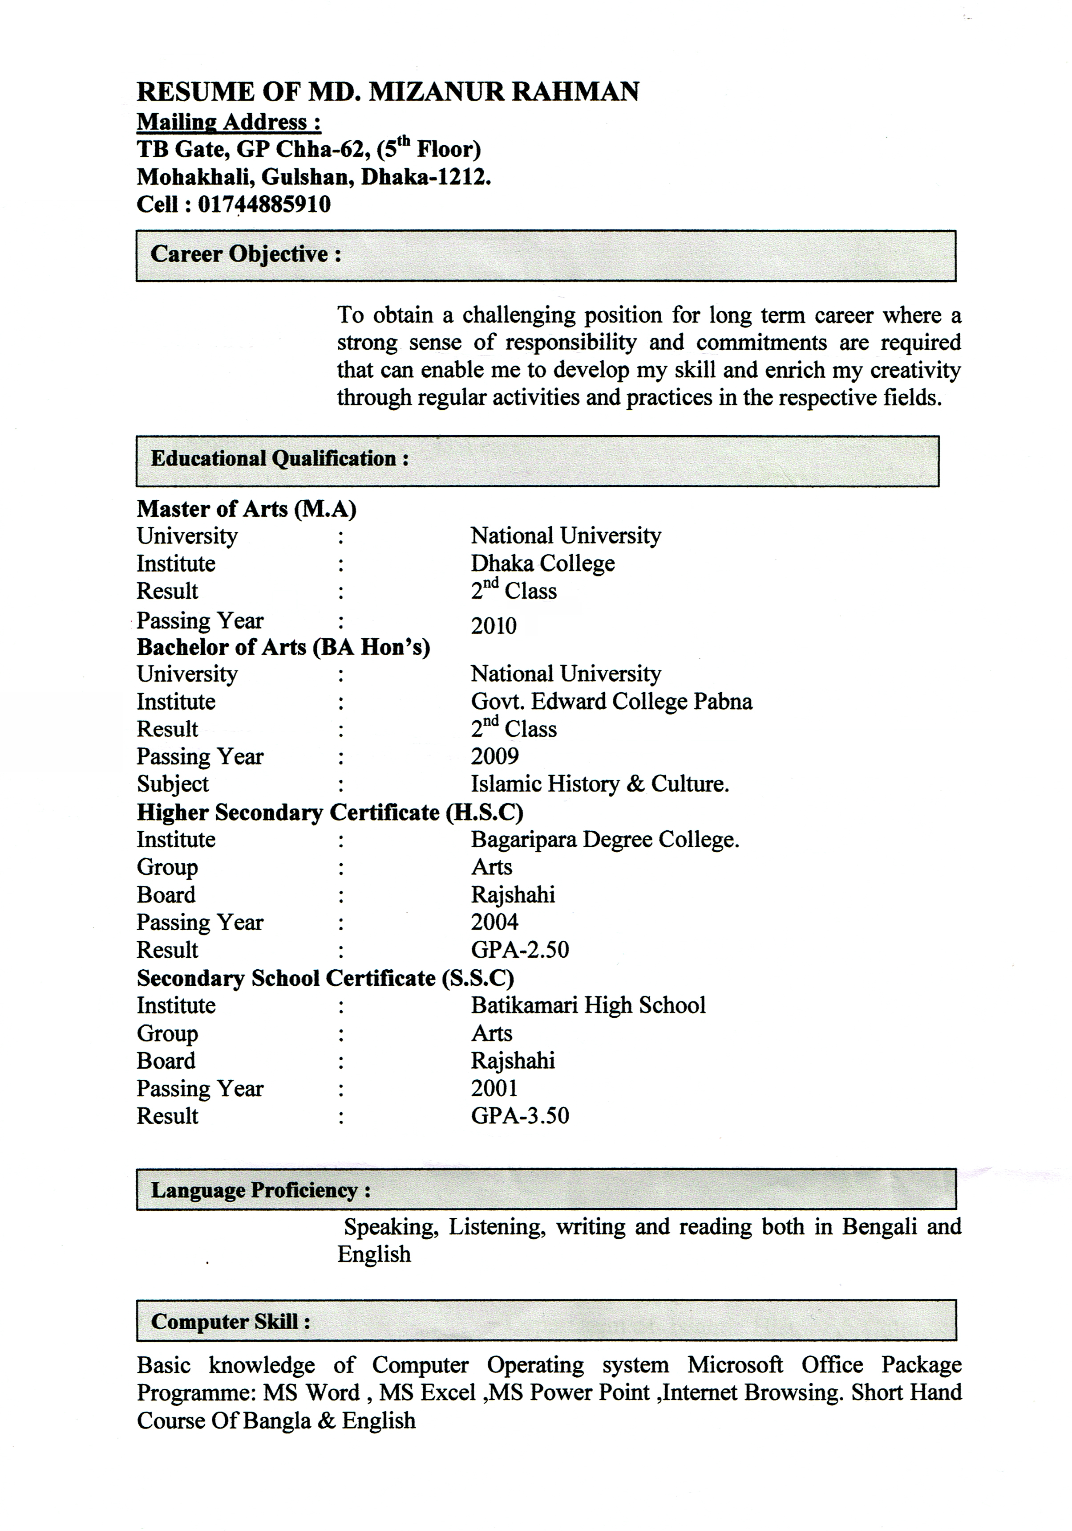

Working Experience:
- Designation : Field Supervisor (FS)
Department : HEM
Office Name : TMSS Dhaka Area
Joining Date : 04-05-2010 to 08-05-2013
Duration : 3 Years

- Designation : Field Employer (FE)
Department : Research and Evaluation Division
Office Name : BRAC
Joining Date : 01-05-2013 to 10-11-2013
Duration : 6 Months

- Designation : Program Organizer (PO)
Department : Water Sanitation And Hygiene (WASH).
Office Name : BRAC
Joining Date : 22-12-2013 to till now.

Personal profile:

Name : Md. Mizanur Rahman
Father’s Name : Md. Zahurul Islam
Mother’s Name : Mst. Momena Begum
Permanent address : Vill, Taltala, Post:- Dayarampur, P.S:-
Bagatipara, Dist: Natore.
Date of Birth : 10-10-1985
Nationality : Bangladeshi (By Birth)
Religion : Islam
Marital Status : Married
Blood Group : A+ve
Gender : Male
Reference:
- Md. Rofikul Islam
Assistant Professor
Department of Botany
Govt. Ullah Para College Sirajgonj.
Call: 01731439394
- Abu Mohammad Nuruddin
Assistant Professor
Department of Islamic History & Culture
Govt. Aziul Haque College Bogra.
Call: 01725321558

Signature
Date:

